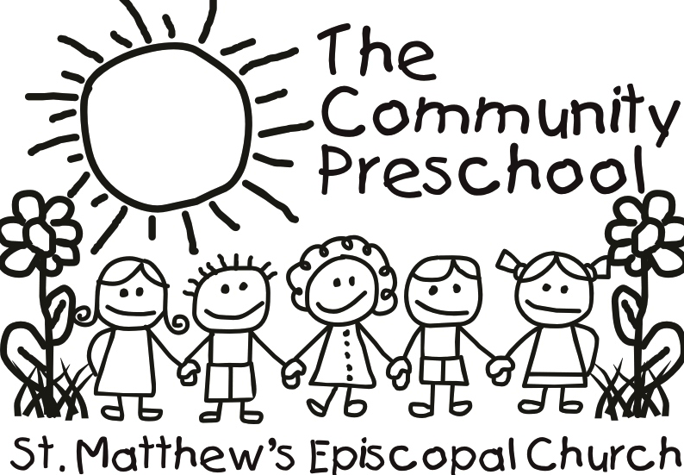

2016 Summer Program

Child/Parents’ name: Age and birthday:
We are only accepting children between the ages of 1 (by April 1, 2015) and 6.

Teachers this year: (if attended Community Preschool)

2 contact phone #s:

Address: Email:

Weeks child will be attending, please circle:

(Where you see two themes listed, the first is for the 3s and up, the second is for the 1s and 2s)

May 31-June3 (4 day week) Nature
June 6-10 Science/Eric Carle
June 13-17 Robots & Rockets/Colors
June 20-24 Five Senses
June 27-July 1 Red, White and Blue

July 5-8 (4 day week) Pirates & Princesses
July 11-15 Cooking
July 18-22 Welcome to the Jungle
July 25-29 Olympics
Aug 1-5 Ocean & Beach Week
Days of the week attending:

(This only applies if you are signing up for less than 5 days each week and are committing to at least 4 weeks of the program for those certain days.)

Monday Tuesday Wednesday Thursday Friday

Payment for May/June due May 23 (5 weeks)
Payment for July/August due June 27 (5 weeks)
Total amount due

