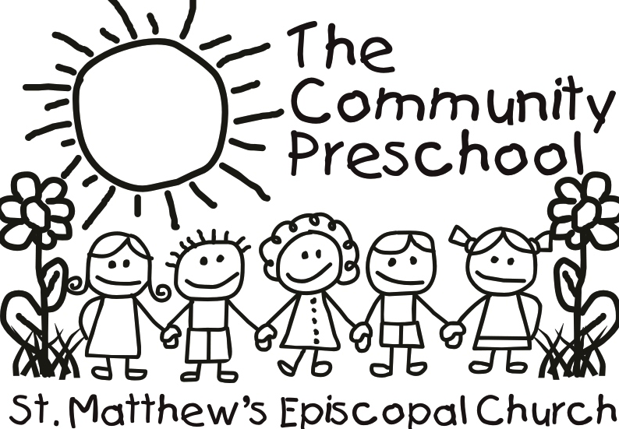

2016 Summer Program

Welcome to the Community Preschool’s 2016 Summer Program! We are so excited to be offering camps again this year and can’t wait to kick off a spectacular summer.

Our camps will be offered from 8:30-1:30 for 10 weeks of the summer. The camps will begin on Tuesday, May 31 and end Friday, August 5. The children will eat lunch (provided by you), but will not have naps here during these hours. We plan to keep the kiddos quite busy and hopefully tire them out so that when you pick them up at 1:30, they will be ready for some down time at home!

We are going to accept children from ages 1 (by April 1, 2015 and ideally walking) to 6. We plan to divide them up into smaller groups to facilitate age-appropriate crafts, activities and play. Just like last year, we will ask that if you are not using 5 days a week that you use the same days each week for at least 4 weeks. This enables us to more effectively handle staffing needs. Additionally, we know that summer schedules can be difficult to nail down, but we are asking that you let us know if your child will be attending at least one full week in advance. If we don’t have that notice the days will be considered drop-in days.

We have added some new themes and kept some of our favorites from years past. Check out the great things your kids could be doing with us! If you have any questions, please feel free to contact Linda Kempf at lekempf@msn.com or 500-6690. You can bring your form and/or payment by the school, or mail them to Community Preschool, 330 N. Hubbards Lane, 40207.
Thanks so much and looking forward to some great summer fun with your kids!

